Module 3: Database Integration
Hands-on 7 : Migrations & Versioning — Alembic and Django Migrations

Task 1: Set Up Alembic and Create a Baseline Migration Goal: Initialise Alembic and generate the first migration from your existing models. Steps:
92. In your project folder, run: alembic init migrations
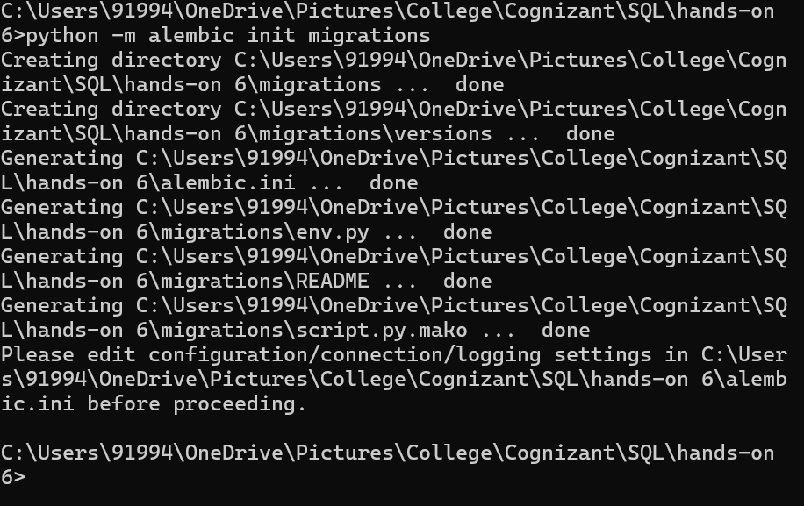
93. Edit alembic.ini to set sqlalchemy.url to your college_db_orm connection string.
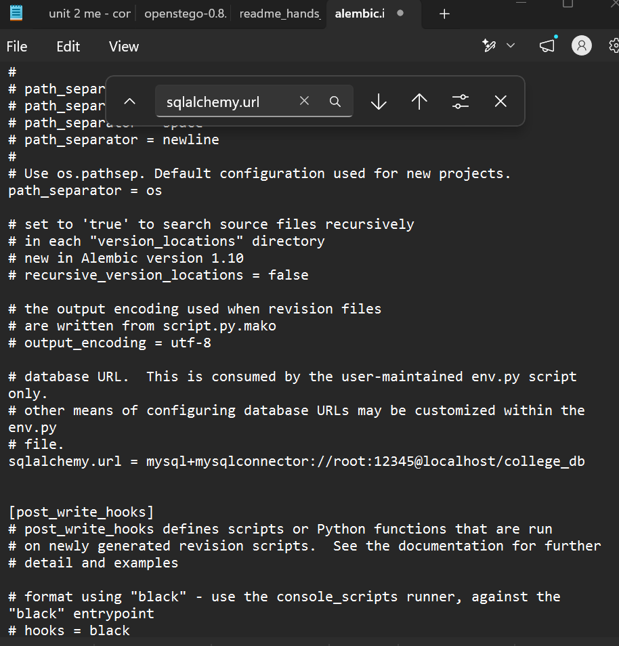
94. Edit migrations/env.py to import your models' Base and set target_metadata = Base.metadata.
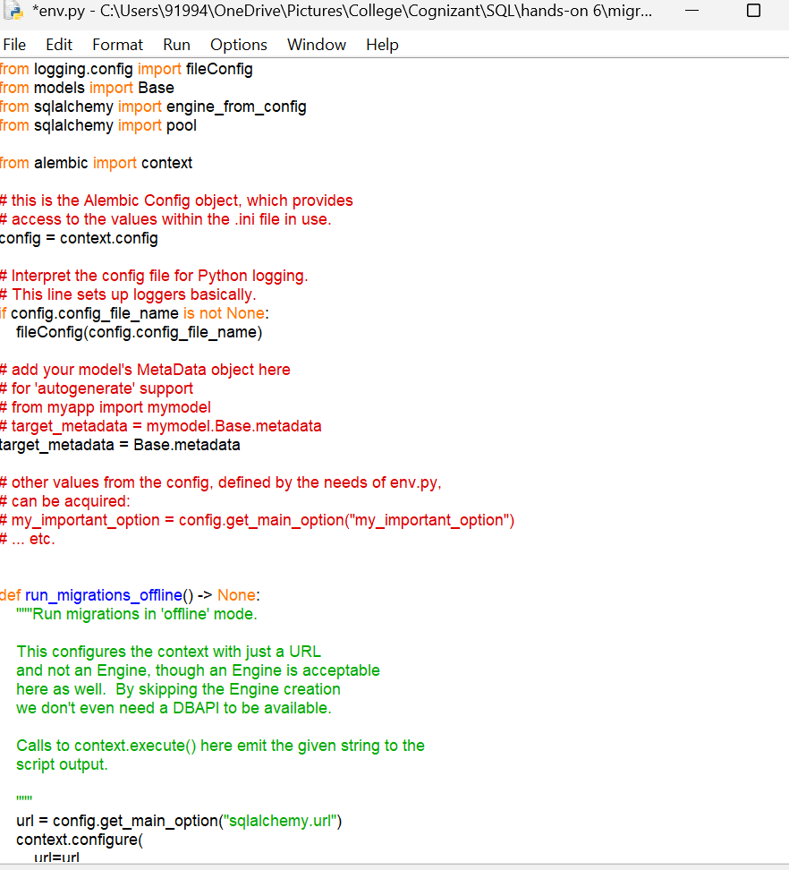
95. Run alembic revision --autogenerate -m 'initial schema' to generate the first migration file.
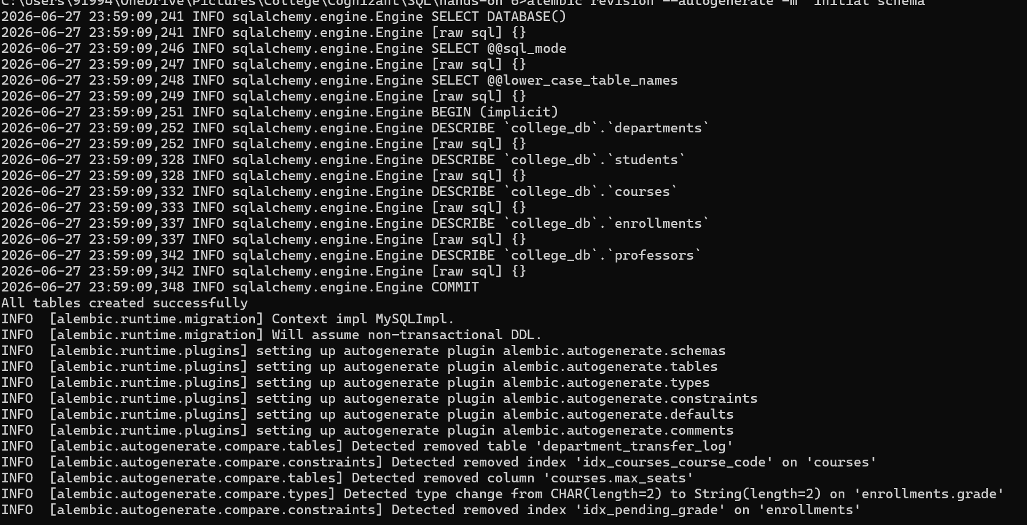

96. Inspect the generated file in migrations/versions/ — confirm it contains the upgrade() and downgrade() functions.
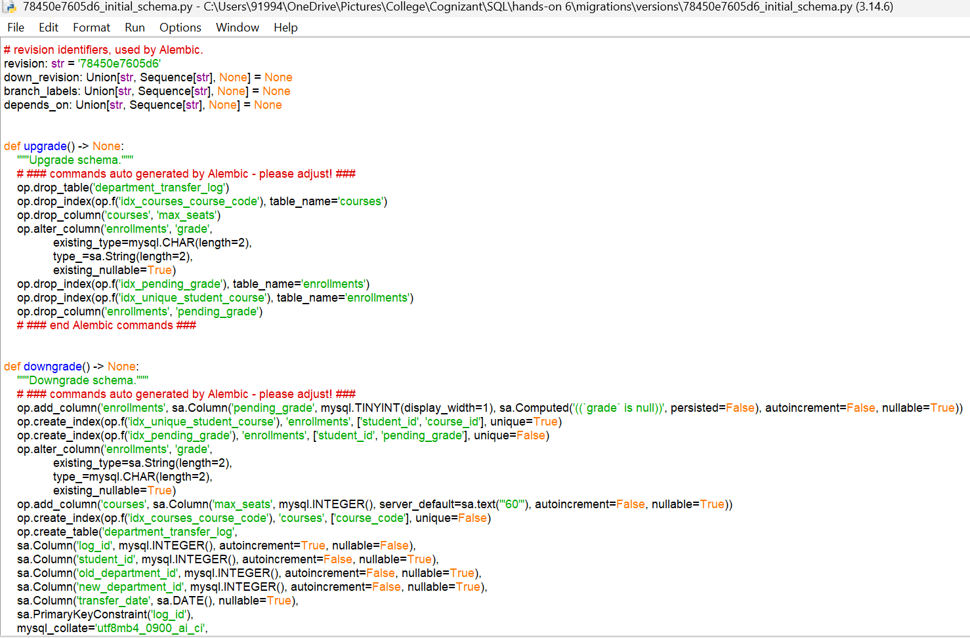

97. Run alembic upgrade head to apply the migration. Verify the alembic_version table is created in your database
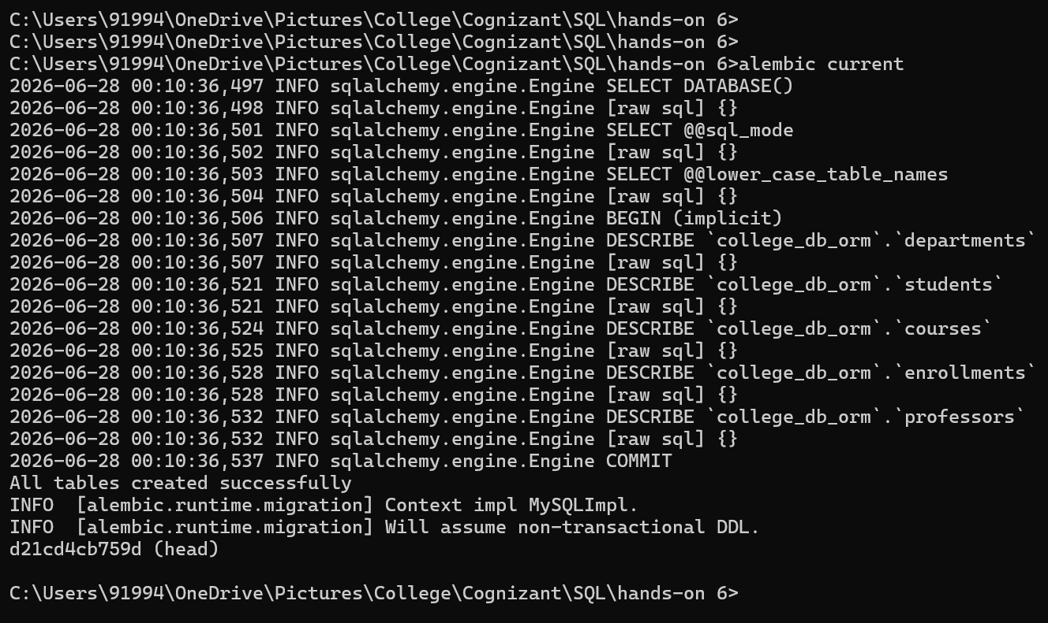

Task 2: Add and Apply Incremental Migrations Goal: Simulate real-world schema evolution with multiple migration revisions. Steps:
98. In models.py, add a new column is_active BOOLEAN DEFAULT TRUE to the Student model.
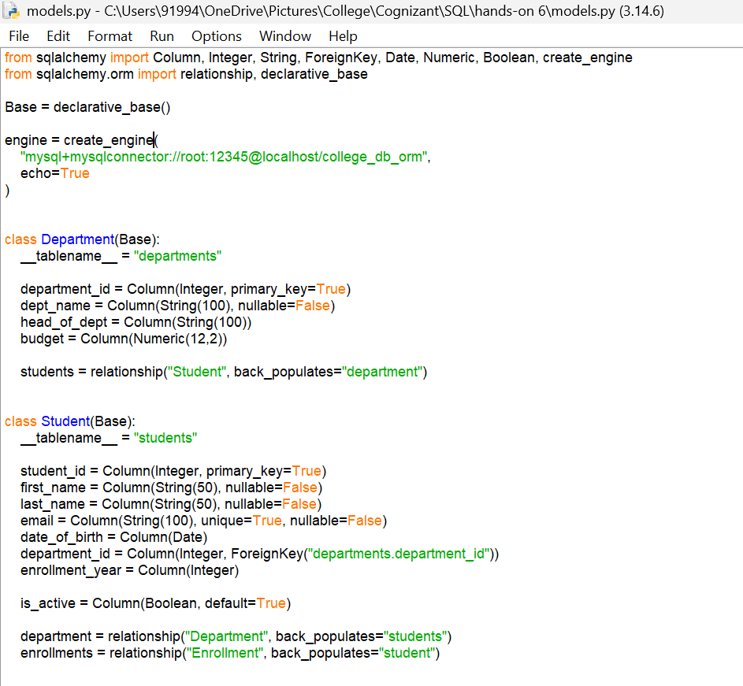

99. Run alembic revision --autogenerate -m 'add is_active to students'.
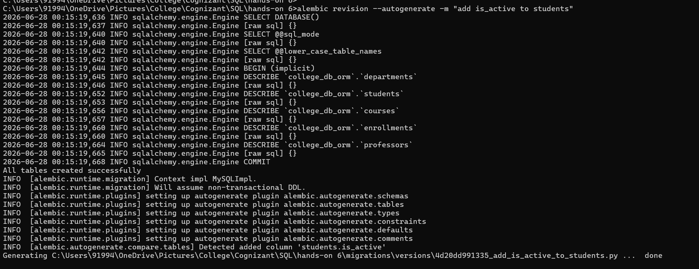

100. Inspect the generated migration — confirm upgrade() adds the column and downgrade() drops it.
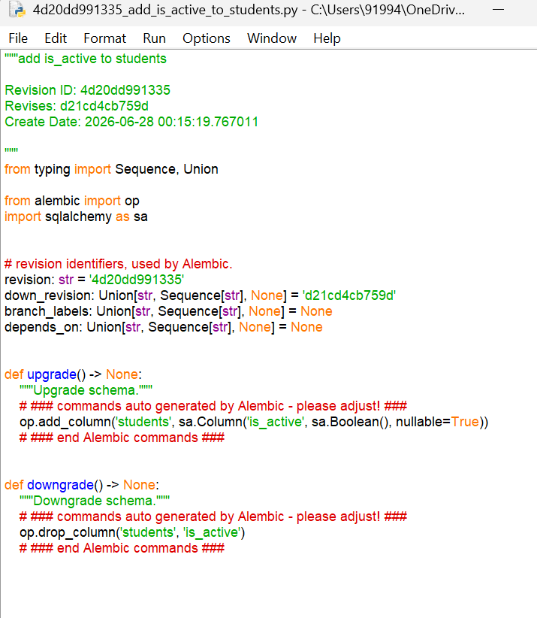

101. Apply with alembic upgrade head. Verify the column exists using your SQL client.
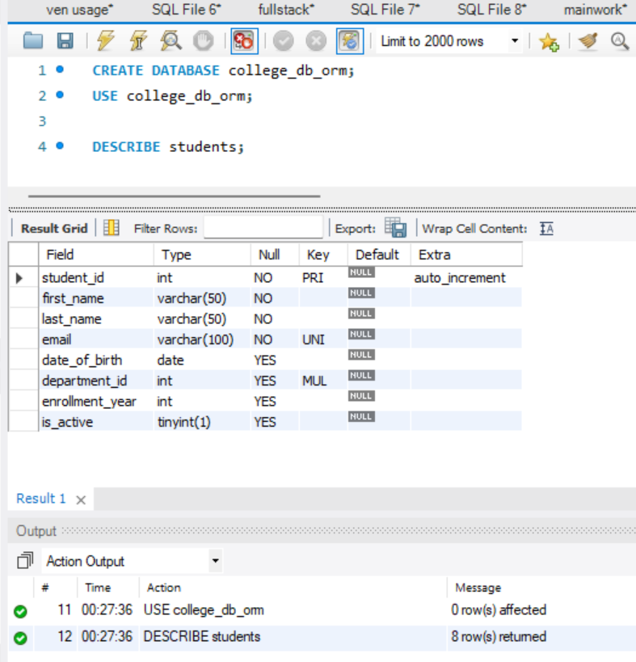

102. Add a new table CourseSchedule with columns: schedule_id, course_id (FK), day_of_week, start_time, end_time. Create the model, generate the migration, and apply it.

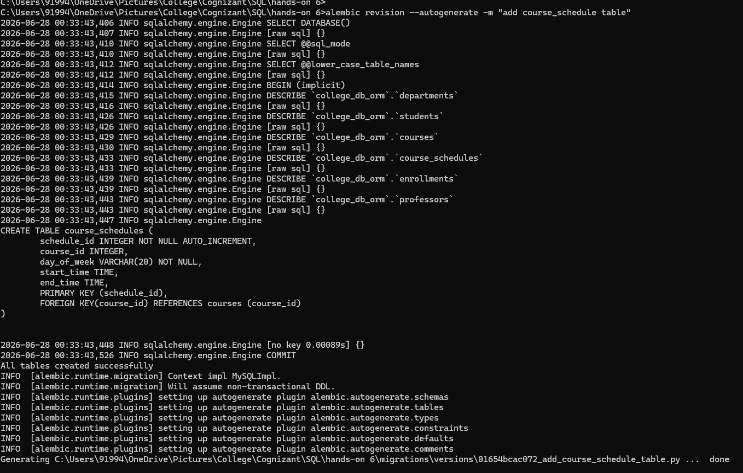

103. Run alembic history --verbose to see the full migration chain.
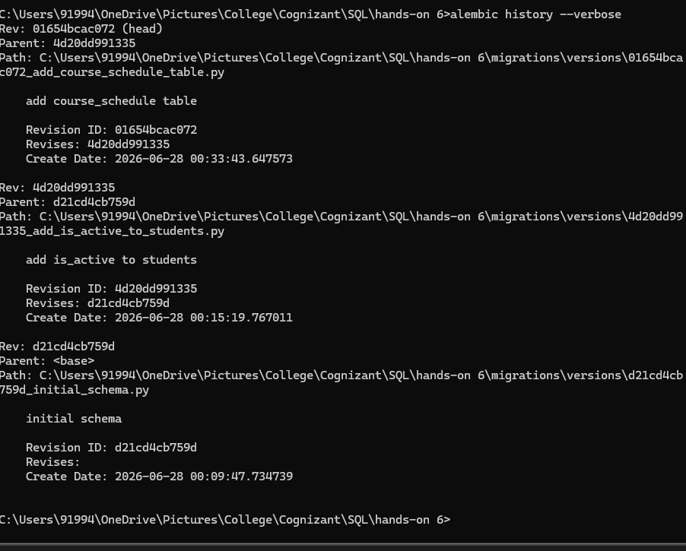

Task 3: Rollback and Recovery Goal: Practise safely reverting to a previous schema version. Steps:
104. Note the current alembic head revision hash using alembic current.
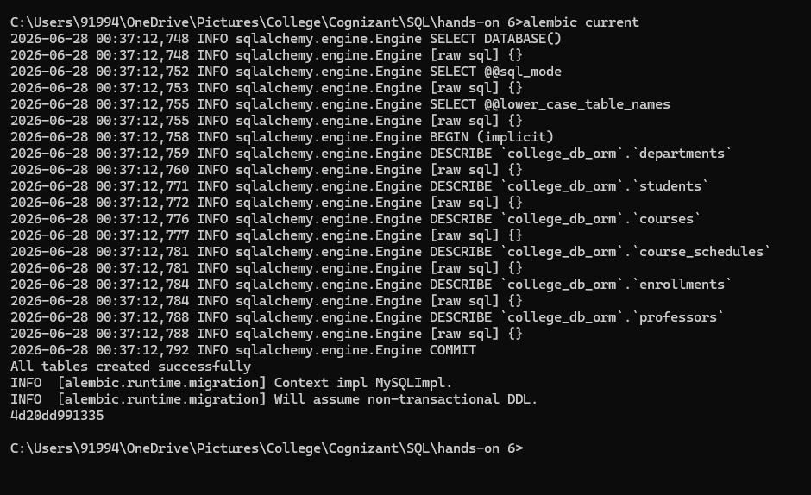
105. Roll back one step using alembic downgrade -1. Confirm the is_active column is dropped.
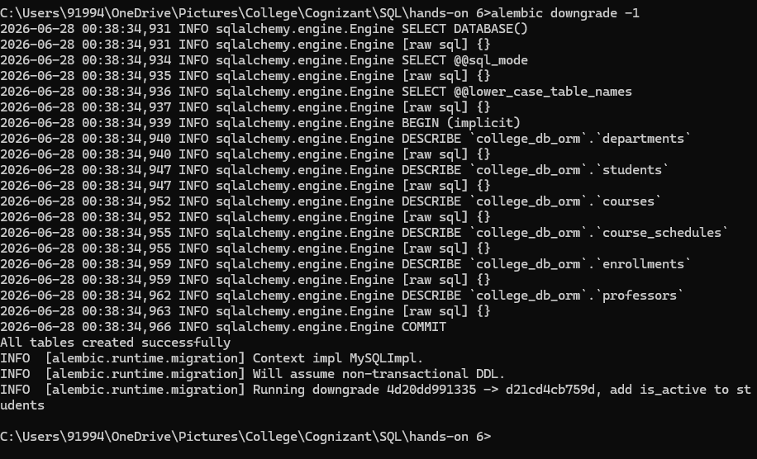

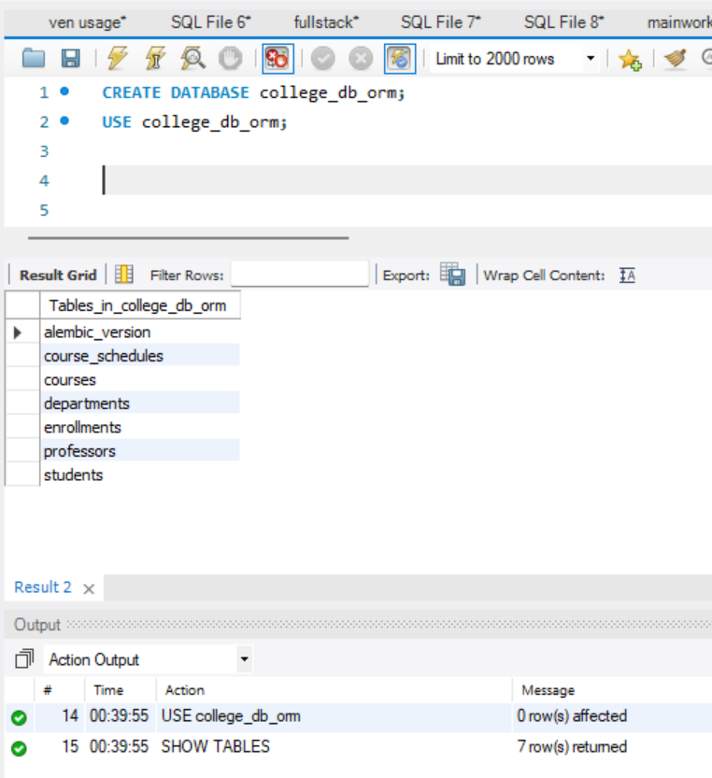

106. Roll back to the very first revision using alembic downgrade base (this undoes all migrations).
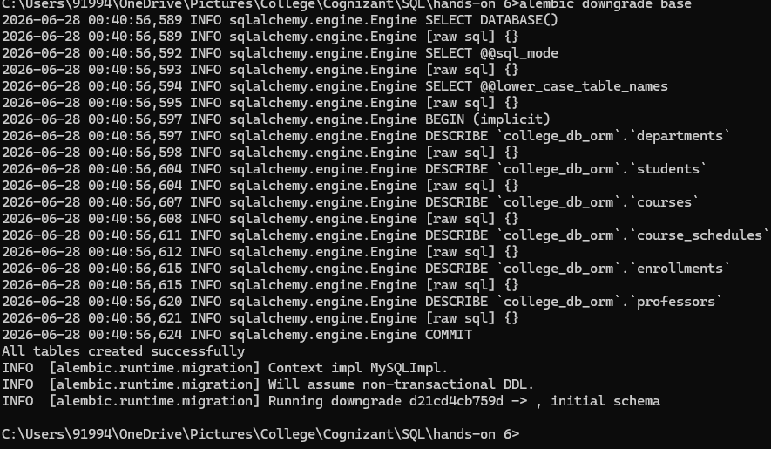
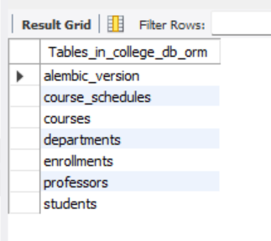
107. Re-apply all migrations with alembic upgrade head and confirm you are back to the latest state.
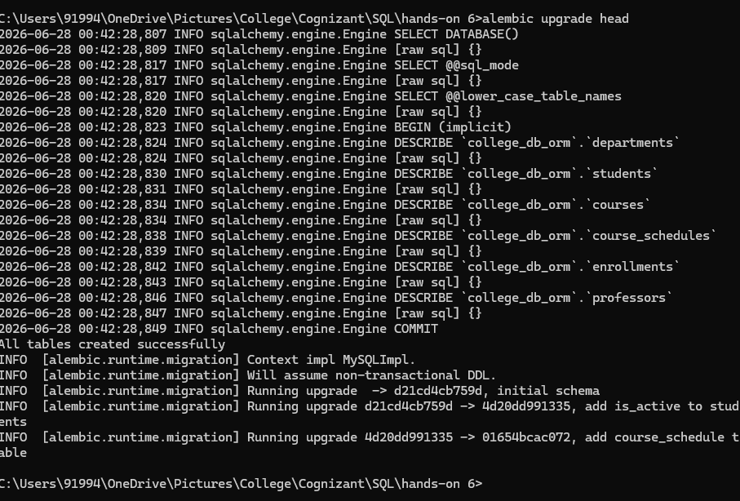
Verify:
